F o s t e r t h e L o v e M i n n e s o t a
“Here to support and serve the foster community of Minnesota.”
T H E N E E D :
In moments of crisis, children leave their homes or schools quickly with nothing or with just a few items put into a trash bag. Foster providers often get less than a few hours to prepare for the child(ren).
T H E P R O V I S I O N :
Foster the Love placement bags. Foster the Love works to break the stigma of the trash bag. These children are not disposable and neither are their belongings. These bags include brand-new, never used items that can bring comfort to the child and provide an immediate need for the foster provider. Items in a placement bag include: A BRAND NEW DUFFLE BAG/BACKPACK, PAJAMA’s, SOCKS/UNDERWEAR, SMALL BLANKET, SMALL STUFFED ANIMAL, BOOK, TOOTHBRUSH/TOOTHPASTE, BATH SOAP/PUFF.
*Please LEAVE TAGS ON & please include a diaper bag for infants. Bags are needed for all ages from babies to teens!
T H E D I S T R I B U T I O N :
Drop off sites are located in 6 counties around the metro! The bags will then be taken to foster agencies around the Twin Cities where social workers will be able to pick out the appropriate bags as needed!
2017 BAG DRIVES
AUGUST 1st – September 30th “BACK TO SCHOOL DRIVE”
NOVEMBER 1st – DECEMBER 31st “HOLIDAY DRIVE”
See the full list of our drop-off sites at www.fosterthelovemn.org OR facebook.com/fosterthelovemn

Two-year-old girl. Six-month-old boy.
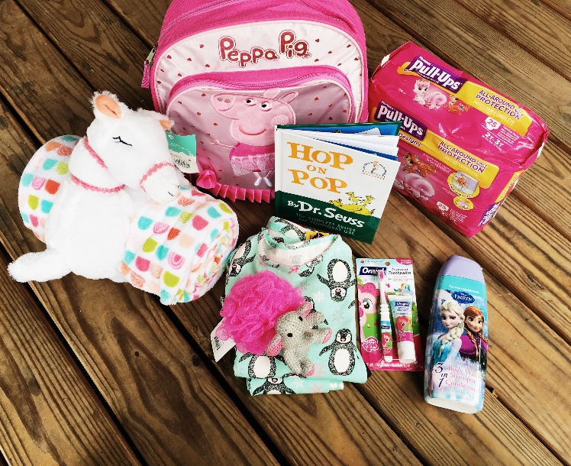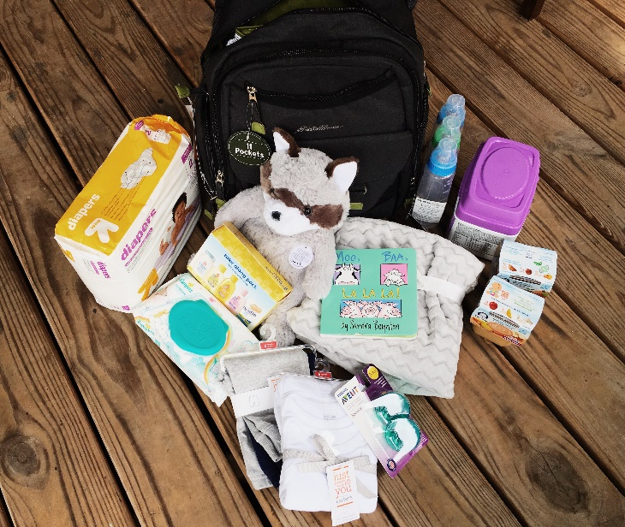
*Please include a zippered bag to ensure items are not lost in transport.
*Call or email for additional questions! 651-592-4015 fosterthelovemn@gmail.com
THANK YOU FOR PARTNERING WITH US TO CARE FOR THESE LITTLE ONES!

