  - F o s t e r t h e L o v e M i n n e s o t a
“Supporting & Serving the Foster Community of Minnesota”

Donate like-new/unused baby items here!
All items will go to foster families here in Minnesota.

Diapers any size -even open packages
Wipes
Formula (unexpired)
Baby cereal
Clothes gently used/like-new
Desitin
Baby lotion
Baby shampoo
Unused bottles
New baby blankets
New baby books
Baby book of memories (to document baby’s “firsts” for mom & dad)

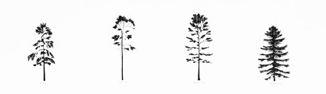

For more information about this organization,
Visit www.fosterthelovemn.org.
Email: fosterthelovemn@gmail.com
Theresa Saum (952) 484-5722
Katie O’Neil (651) 592-4015

